American Youth Soccer Organization
EXPENSE REIMBURSEMENT GUIDELINES FOR Region 862
FUNDS by AYSO REGIONAL VOLUNTEERS
Updated: 2017

The following has been established to provide Regional Members and other volunteers with guidelines regarding policies related to Regional reimbursement of expenses incurred by volunteer
I. PROCEDURES
- Prior to submitting any AYSO-related expenses or obligations, volunteers should obtain approval from the appropriate Approving Authority (Regional Commissioner) as to who will review it for budgetary control and program impact. Any expense may be disapproved by the Region if it is determined not to be compliant/ in accordance with parameters established.
- Expenses to be reimbursed by the Region 862 must be submitted on an AYSO Expense Reimbursement form. The Expense Reimbursement form must be submitted to the Region 862 Treasurer within 60 days of the date the expense was incurred. Late filing may result in denial of reimbursement. The reimbursement form must be signed by the requesting party and the RC. All original itemized receipts must be attached to the report prior to submittal for payment. Copies of receipts are not acceptable and expense submission may be returned.
REIMBURSEMENT REQUEST FORM
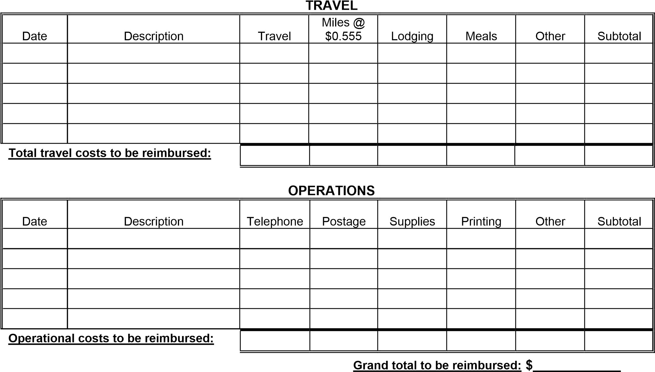

Payable to: ____________________________________________________ Date: _____ / ______ / ______
Address: ______________________________________________________
AYSO Position: Section: 8 Area: D Region: 862
I hereby certify that the above is a true and correct statement of expenses incurred by me for Region 862.

Signature Requestor
NOTE: All requests for reimbursement must be within an acceptable time from the date incurred and must be accompanied with ORIGINAL ITEMIZED RECEIPTS. Failure to follow this procedure will result in
Disallowance of the request. Send this form to: The Regional Commissioner for approval and once
Approved. Regional Commissioner will forward to Region 862 Treasurer.

